MOHIT V – 192512043 ECA1304 MICROWAVE ENGINEERING
EXP 1 Simulation-Based Electromagnetic Analysis of TEM, TE and TM Propagation Modes in Microwave Transmission Structures
AIM:
To simulate and analyze the TEM, TE₁₀ and TM₁₁ modes in microwave transmission structures using MATLAB, and to study their field distributions, cutoff frequencies and propagation characteristics.
PROCEDURE:
- Define the dimensions of the WR-90 rectangular waveguide:
  - $a=22.86$mm
  - $b=10.16$mm
  - Operating frequency $f=10$GHz.
- Calculate the cutoff frequency using:
$$f_{c}=\frac{c}{2}\sqrt{{\left(\frac{m}{a}\right)}^{2}+{\left(\frac{n}{b}\right)}^{2}}$$
- Calculate the propagation constant:
$$β=\frac{2πf}{c}\sqrt{1-{\left(\frac{f_{c}}{f}\right)}^{2}}$$
- Generate MATLAB plots to visualize the electric and magnetic field distributions for TE₁₀ and TM₁₁ modes.
- Compare the cutoff frequencies and propagation behavior of TE₁₀ and TM₁₁.
- Represent the TEM mode and compare its propagation characteristics with TE and TM modes.
- Analyze the obtained graphs and verify the results with theoretical values.
OBJECTIVES AND CODE
OBJECTIVE 1
clc;
clear;
close all;

c = 3e8;
f = 10e9;

% WR-90 dimensions
a = 22.86e-3;
b = 10.16e-3;

% TEM mode
beta_TEM = 2*pi*f/c;

% TE10 mode
fc_TE10 = c/(2*a);
beta_TE10 = 2*pi*f/c*sqrt(1-(fc_TE10/f)^2);

% TM11 mode
fc_TM11 = (c/2)*sqrt((1/a)^2+(1/b)^2);

if f > fc_TM11
beta_TM11 = 2*pi*f/c*sqrt(1-(fc_TM11/f)^2);
else
beta_TM11 = 1i*(2*pi*f/c)*sqrt((fc_TM11/f)^2-1);
end

fprintf('TEM beta = %.2f rad/m\n',beta_TEM);
fprintf('TE10 cutoff = %.3f GHz\n',fc_TE10/1e9);
fprintf('TE10 beta = %.2f rad/m\n',beta_TE10);
fprintf('TM11 cutoff = %.3f GHz\n',fc_TM11/1e9);
fprintf('TM11 beta = ');
disp(beta_TM11);
OBJECTIVE 2
clc;
clear;
close all;

a = 22.86e-3;
b = 10.16e-3;

x = linspace(0,a,100);
y = linspace(0,b,60);

[X,Y] = meshgrid(x,y);

% TE10 fields
E_TE10 = sin(pi*X/a);
H_TE10 = cos(pi*X/a);

% TM11 fields
E_TM11 = sin(pi*X/a).*sin(pi*Y/b);
H_TM11 = cos(pi*X/a).*cos(pi*Y/b);

% TE10 E-field
figure;
surf(X*1000,Y*1000,E_TE10);
shading interp;
xlabel('x (mm)');
ylabel('y (mm)');
zlabel('E-field');
title('TE10 E-field');
colorbar;

% TE10 H-field
figure;
surf(X*1000,Y*1000,H_TE10);
shading interp;
xlabel('x (mm)');
ylabel('y (mm)');
zlabel('H-field');
title('TE10 H-field');
colorbar;

% TM11 E-field
figure;
surf(X*1000,Y*1000,E_TM11);
shading interp;
xlabel('x (mm)');
ylabel('y (mm)');
zlabel('E-field');
title('TM11 E-field');
colorbar;

% TM11 H-field
figure;
surf(X*1000,Y*1000,H_TM11);
shading interp;
xlabel('x (mm)');
ylabel('y (mm)');
zlabel('H-field');
title('TM11 H-field');
colorbar;
OBJECTIVE 3
clc;
clear;

c = 3e8;

a = 22.86e-3;
b = 10.16e-3;
f = 10e9;

% TE10
m = 1;
n = 0;

fc_TE10 = (c/2)*sqrt((m/a)^2+(n/b)^2);

k0 = 2*pi*f/c;

beta_TE10 = k0*sqrt(1-(fc_TE10/f)^2);

% TM11
m = 1;
n = 1;

fc_TM11 = (c/2)*sqrt((m/a)^2+(n/b)^2);

if f > fc_TM11
beta_TM11 = k0*sqrt(1-(fc_TM11/f)^2);
else
beta_TM11 = 1i*k0*sqrt((fc_TM11/f)^2-1);
end

fprintf('--- RESULTS ---\n');

fprintf('TE10 cutoff frequency = %.3f GHz\n',fc_TE10/1e9);

fprintf('TE10 propagation constant = %.2f rad/m\n',beta_TE10);

fprintf('TM11 cutoff frequency = %.3f GHz\n',fc_TM11/1e9);

fprintf('TM11 propagation constant = ');
disp(beta_TM11);
OBJECTIVE 4
clc;
clear;

c = 3e8;
f = 10e9;

a = 22.86e-3;
b = 10.16e-3;

% TEM
fc_TEM = 0;
beta_TEM = 2*pi*f/c;

% TE10
fc_TE10 = c/(2*a);
beta_TE10 = 2*pi*f/c*sqrt(1-(fc_TE10/f)^2);

% TM11
fc_TM11 = (c/2)*sqrt((1/a)^2+(1/b)^2);

fprintf('MODE COMPARISON\n');
fprintf('-----------------------------\n');

fprintf('TEM : fc = 0 GHz, beta = %.2f rad/m\n',beta_TEM);

fprintf('TE10 : fc = %.3f GHz, beta = %.2f rad/m\n',...
fc_TE10/1e9,beta_TE10);

fprintf('TM11 : fc = %.3f GHz\n',fc_TM11/1e9);

fprintf('\nPROPAGATION ANALYSIS\n');

if f > fc_TE10
fprintf('TE10 -> PROPAGATES\n');
else
fprintf('TE10 -> EVANESCENT\n');
end

if f > fc_TM11
fprintf('TM11 -> PROPAGATES\n');
else
fprintf('TM11 -> BELOW CUTOFF\n');
end

fprintf('\nPRACTICAL SUITABILITY\n');
fprintf('TEM -> Coaxial transmission lines\n');
fprintf('TE10 -> Dominant mode in rectangular waveguides\n');
fprintf('TM11 -> Higher-order mode; not propagated at 10 GHz\n');
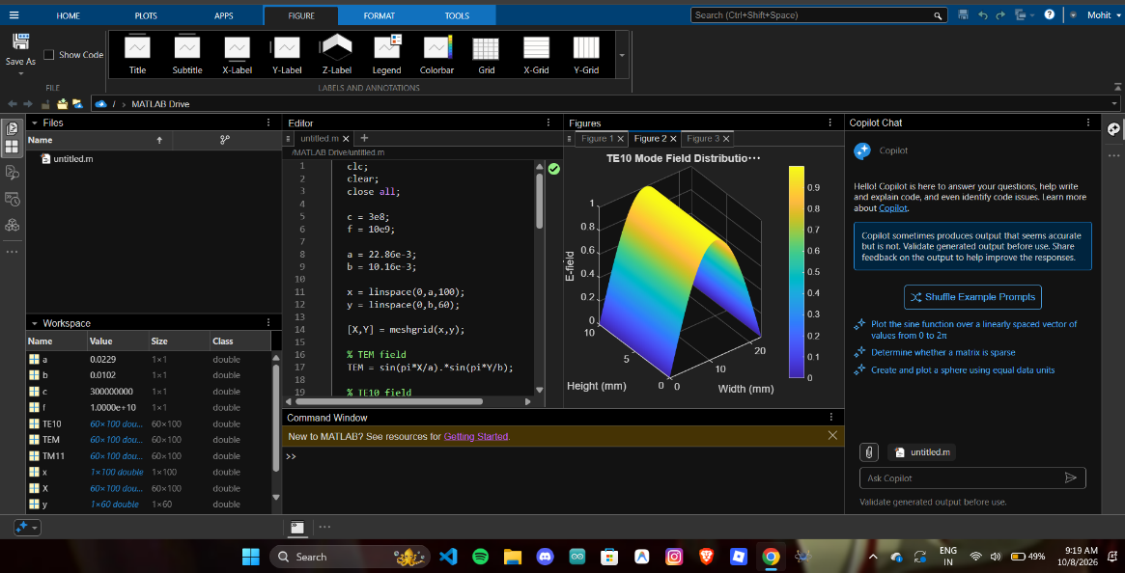
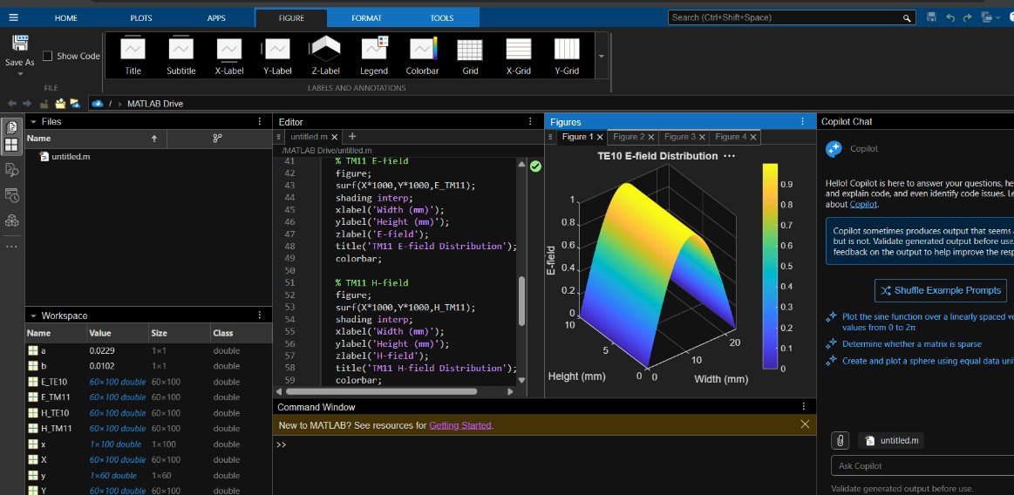
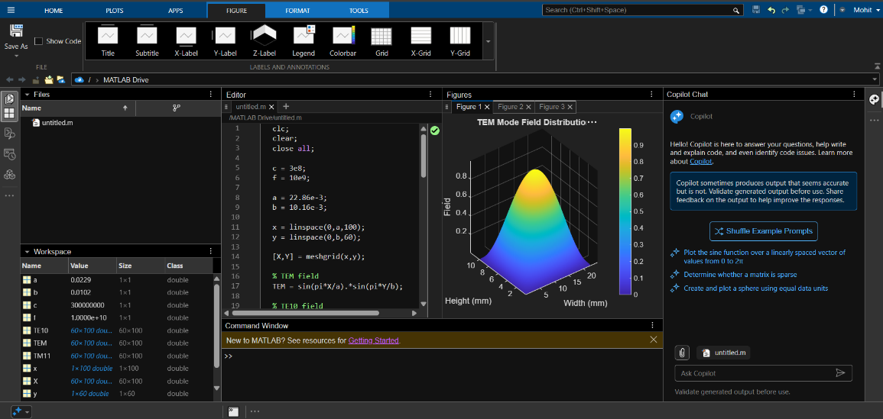

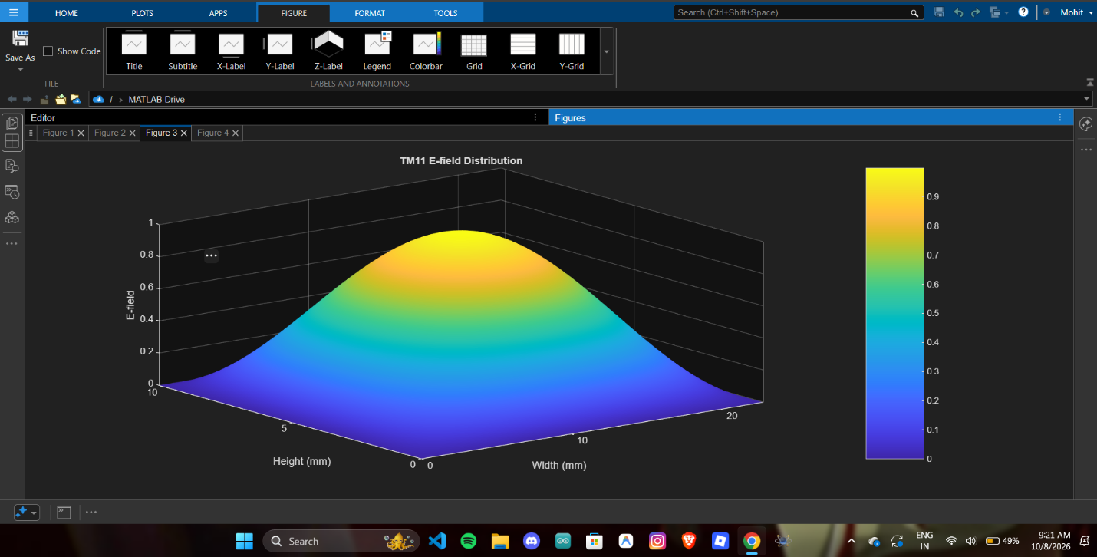
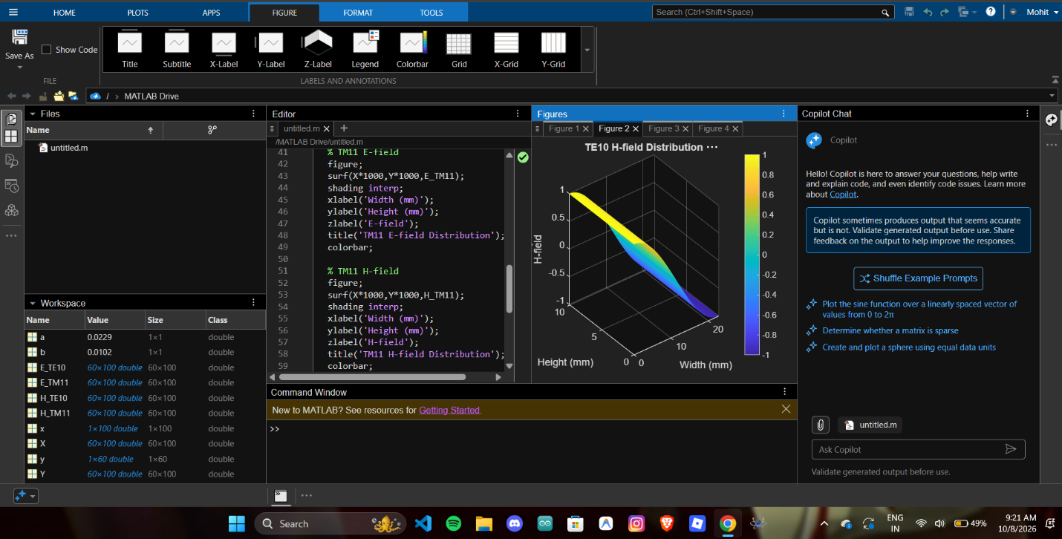
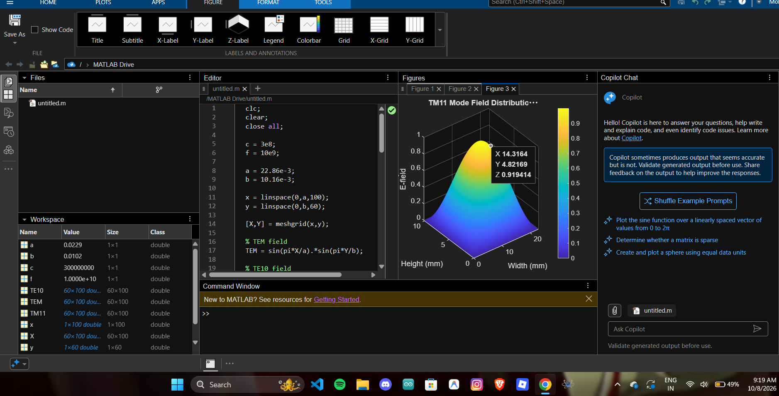
RESULTS
The TEM, TE₁₀ and TM₁₁ modes were successfully simulated using MATLAB.
- TE₁₀ cutoff frequency: ≈ 6.56 GHz
- TM₁₁ cutoff frequency: ≈ 16.42 GHz
- At 10 GHz, TE₁₀ propagates since $f>f_{c}$.
- At 10 GHz, TM₁₁ is below cutoff and therefore does not propagate.
- TE₁₀ was identified as the dominant mode of the WR-90 waveguide.
- TEM mode has no cutoff frequency in an ideal TEM transmission line.
Thus, the field distributions and propagation characteristics of TEM, TE and TM modes were successfully analyzed.

